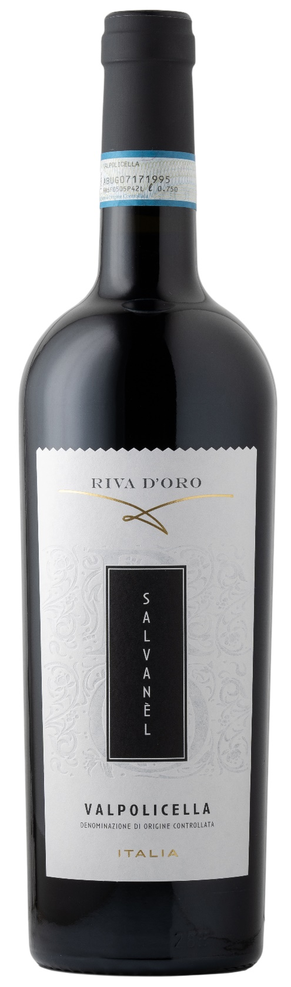
VALPOLICELLA DOCG – SALVANEL

Grape: Corvina, Rondinella
Alc. Vol.%: 12,5
Vintage: 2024
Residual sugar g/l: 4,9
Total acidity g/l: 5,5
Region: Veneto
Production zone: Vineyards in the Valpolicella area
Capacity: 750ml, 1500ml

CHARACTERISTICS

Vinification: Gentle pressing of the grapes, followed by peel maceration in steel tanks at a controlled temperature
Aging: In steel tanks until bottling
Yield per ha: 12000kg
Colour: Brillian red with violet reflections
Bouquet: Fruit notes of red berries
Flavour: Elegant and dry

SERVING SUGGESTIONS

Best enjoyed with chicken and red meat.
Serving temperature 16-18 °C
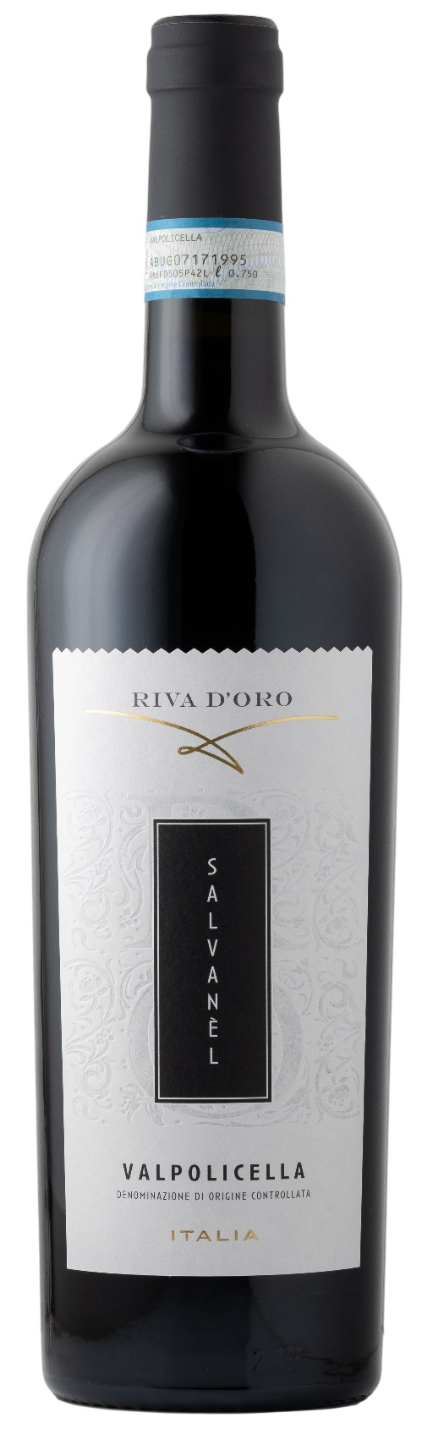
TECHNICAL INFORMATION / PALLETIZING

Size 750ml:
Article Nr. V09004A
GTIN-13 bottle 8017868000662
GTIN-13 carton 8017868004257
Closure Cork
Bottles / carton 6 bottles
Pallet size 80x120cm
Cartons/layer 21
Cartons/pallet 105
Kg/carton 7,8
Kg/pallet 840

Size 1500ml:
Article Nr. V09003B
GTIN-13 bottle 8017868002444
GTIN-13 carton 8017868004509
Closure Screwcap
Bottles / carton 6 bottles
Pallet size 80x120cm
Cartons/layer 14
Cartons/pallet 56
Kg/carton 13,4
Kg/pallet 960

Contains sulphites
GMO Free
Revisione 01. 14.05.2026

